**User:**

I like the minimalist and sleek design style of the energy harvesting device. It should look clean and modern without unnecessary details.

For this project, I favoured a bio-inspired design approach, using principles found in nature to optimise energy harvesting.

Based on the above background, I will be designing an energy harvesting device.

The energy harvesting device shall require three key modules:

1. The energy accumulation module functions to derive energy from an external source outside the energy harvesting device.

2. The energy storage module functions to store the accumulated energy inside the energy

harvesting device.

3. The energy utilization module utilizes the harvested energy to power other small devices such as sensors, heating/cooling devices, actuators, and low-power devices.

Please give me as many and reasonable and complete designs as possible.

**GPT:**

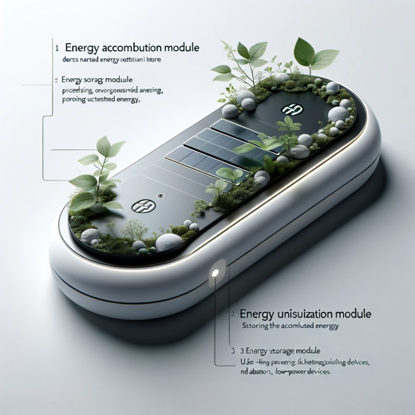

Here is a design for an energy harvesting device that aligns with your specifications. This design incorporates a minimalist and sleek style, inspired by nature, and includes three key modules: energy accumulation, energy storage, and energy utilization. The device is crafted to be clean and modern, without unnecessary details, reflecting a fusion of technology and natural principles.

**User:**

Based on the information I provided earlier, are there any other details I should provide regarding the design of the energy harvesting device?

**GPT:**

Your initial description for the energy harvesting device is quite comprehensive, but here are a few additional aspects you might consider specifying to further refine the design:

1. **Material Choices**: Specify materials that are both functional and align with your design aesthetics. For instance, you could consider lightweight, durable materials, or eco-friendly options.
2. **Size and Portability**: Clarify the intended size and portability of the device. Should it be compact and handheld, or larger and stationary?
3. **Energy Source**: Detail the specific external energy sources the device will harness. For example, will it use solar, wind, thermal, kinetic, or a combination of these?
4. **Power Output Specifications**: Define the expected power output or the range of devices it should be capable of powering. This will impact the design of the energy utilization module.
5. **Environmental Conditions**: Indicate the environmental conditions the device will operate in, such as temperature range, exposure to elements, or specific geographic considerations.
6. **User Interface and Controls**: If applicable, describe the user interface and control mechanisms. Should it have a digital display, buttons, touch controls, or remote operation capabilities?
7. **Safety Features**: Outline any necessary safety features, such as overheating protection, electrical insulation, or weatherproofing.
8. **Maintenance and Durability**: Provide guidelines on the expected maintenance needs and durability. How often should it be serviced, and what is the anticipated lifespan?
9. **Cost Constraints**: If there are any budgetary limits, specifying these can help in selecting appropriate materials and technologies.
10. **Aesthetic Details**: If there are specific color schemes, textures, or stylistic elements you prefer, mentioning these can help in visualizing the final product.

Providing these additional details can help in creating a more tailored and functional design for your energy harvesting device.

**User:**

I like the minimalist and sleek design style of the energy harvesting device. It should look clean and modern without unnecessary details.

The energy harvesting device is planned to be deployed in a coastal urban environment in Australia. The design needs to take into account the city where it will be applied to ensure consistent energy output throughout the year. Installation must be straightforward. In terms of maintenance, the unit should be designed to minimise the need for frequent repairs and, where necessary, key components should be easily accessible.

The equipment must comply with Australian Standards for Electrical Equipment. The design should be compact to fit into the limited urban space where the installation is specified. Considering the budget of A$50,000, we should prioritise durable materials, balancing cost and longevity.

Based on previous outputs and above information, please give me as many and reasonable and complete designs as possible.

**GPT:**

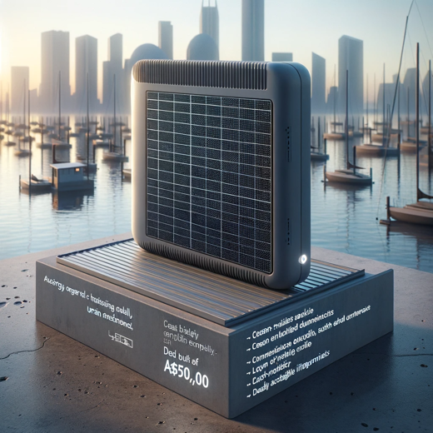

Here is a design concept for the energy harvesting device tailored to your specified requirements. This design takes into account the coastal urban environment in Australia, ensuring a compact form factor for limited urban spaces, ease of installation, low maintenance needs, and compliance with Australian Standards for Electrical Equipment. The design also considers the A$50,000 budget, focusing on durable materials that balance cost and longevity while maintaining a clean, modern aesthetic.

**User:**

Based on the design you gave me above, please explain each module specifically.

**GPT:**

Certainly! Let's break down the design of the energy harvesting device into its three key modules, considering the specific needs of a coastal urban environment in Australia:

1. **Energy Accumulation Module**:
   * **Function**: This module is responsible for capturing and converting ambient energy into a usable form. Given the coastal urban setting, it might utilize solar, wind, or even kinetic energy from ocean waves or urban movements.
   * **Design Aspects**: The design should include efficient energy collectors like photovoltaic cells for solar energy, small wind turbines, or kinetic energy harvesters. The sleek and compact design ensures it seamlessly integrates into the urban landscape without taking up much space.
2. **Energy Storage Module**:
   * **Function**: This module stores the energy accumulated by the first module. It's crucial for ensuring a consistent energy supply, especially when the primary energy source is not available (e.g., solar energy during nighttime).
   * **Design Aspects**: The storage unit could be composed of advanced batteries or supercapacitors, designed to maximize storage capacity while maintaining a small footprint. It should be housed in a durable, weather-resistant casing to protect against coastal elements like saltwater corrosion.
3. **Energy Utilization Module**:
   * **Function**: This module manages the distribution and use of the stored energy. It powers small devices and systems, potentially including sensors, actuators, or even public lighting and charging stations in the urban environment.
   * **Design Aspects**: It should include efficient energy conversion systems and smart management circuits to optimize energy distribution based on demand. The design might feature modular outlets or connections for various applications, with user-friendly interfaces for easy interaction.

Each module in this design is tailored to the unique requirements of a coastal urban setting in Australia, focusing on minimalism, efficiency, and durability. The device's overall design is intended to be unobtrusive, modern, and in compliance with local standards, ensuring it fits well within the specified budget and urban aesthetic.